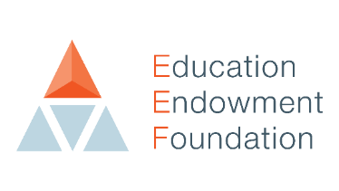
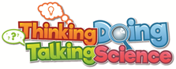

Expression of Interest in Thinking, Doing, Talking Science

Yes, I would like to find out more about how my school can participate in the Thinking, Doing and Talking Science project and access a free Thinking, Doing Talking Science CPD course during 2022-23. Please send me further information and an invitation to an online conference.

Name of School:
Address of School:

Name of Head Teacher:
Contact Name and E-mail:
Number of Year 5 teachers in school:

Recruitment of schools for the main Thinking, Doing, Talking Science re-effectiveness trial will commence in January 2022. Training for teachers will take place in the academic year beginning September 2022.

Please respond to your local contact:

